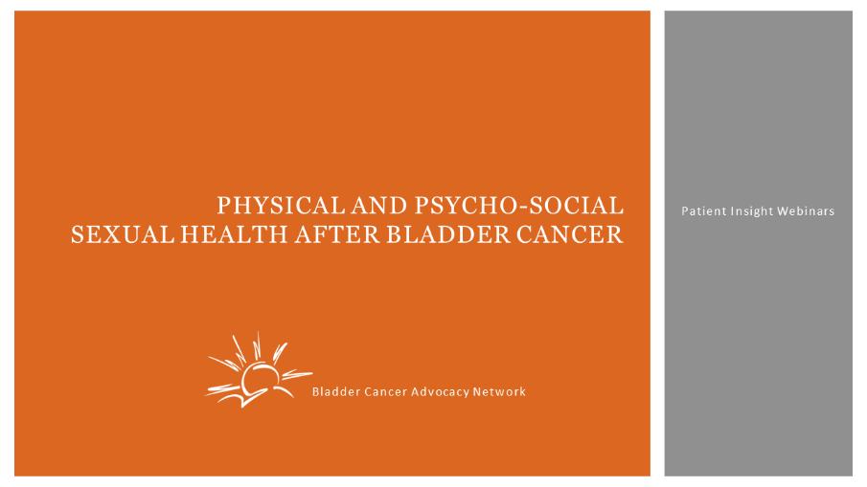
Stephanie Chisolm:
Hello. Welcome to physical and psycho-social sexual health after bladder cancer. This is a patient insight webinar from the bladder cancer Advocacy Network and is supported by our sponsor, the EMD-Pfizer partnership. After bladder cancer diagnosis, the conversation about how to live your life fully following treatment doesn't always occur. Sexuality is a big portion of your life, and maybe it's not as important anymore, but the sexual function is still important. And changes in sexual function are often a common phenomena that many bladder cancer patients experience, both men and women. Sexual health is frequently overlooked both by the patient and sometimes by the doctor in discussions prior to treatment. BCAN is very delighted to have with us tonight two experts; Dr. Svetlana Avulova, and social worker and AASECT certified sex therapist, Melissa Donahue. We're going to talk about the physical and mental aspect of bladder cancer treatments on sexual function.

Dr. Avulova, who will be joining us shortly, cares for patients with urologic malignancies, including urothelial carcinoma. She completed her urologic oncology training at the Mayo Clinic in Rochester, Minnesota, and is now at the Albany Medical Center in New York. She has a special interest in raising awareness about bladder cancer in women, especially because they're more likely to be diagnosed at much later stages. And she's focused a lot of her research on the sexual impact of bladder cancer on both men and women, and she's really a rising star in terms of expertise on resolving some of those issues.

Ms. Melissa Donahue is a certified sex therapist and she has been working with the American Association of Sexuality Educators, Counselors and Therapists. And she's only one of 900, I believe, that they have out there. So this is rare that we've got a wonderful sex therapist who is available to us, to be part of today's program. She's trained at the Institute for Sexual Medicine at the Boston University School of Medicine with Dr. Irwin Goldstein, who is one of the top leaders in the field of sexual medicine. She holds the Louis Lowy Certificate in Gerontological Social Work for her studies and research on aging and elderly issues at Boston University, which is included in an internship at All Care VNA in Lynn, Massachusetts. Ms. Donahue is enrolled in the doctoral program in the School of Social Work and Rutgers University Graduate School in New Brunswick, New Jersey. So welcome so much Melissa. It's a pleasure to have you here. We’ll go ahead and let you start talking about some of the psycho-social aspects of that.
Melissa Donahue:
Great. Well, I want to thank you so much for having me. I'm very excited to come and speak with you tonight about how sexuality is affected after a bladder cancer diagnosis and treatment. We're going to talk about sex and sexuality in a probably different way than you've ever experienced it before. I think most of us, when we were younger, when we learned about the topic of sex and sexuality, we learned it from a biological standpoint or a biological lens, and focused mostly on reproduction. Every time people think about sex, they think really about heterosexual penis and vagina, and vaginal sex, but there's more to sex than just that. And I want to kind of break it down for us as we go forward, so we can make sure that we're all speaking the same language with the same knowledge.

So when it comes to what is sexuality, I think it's important to really define all of these pieces of what sexuality is, to really understand the whole aspect of it and how it can be impacted.
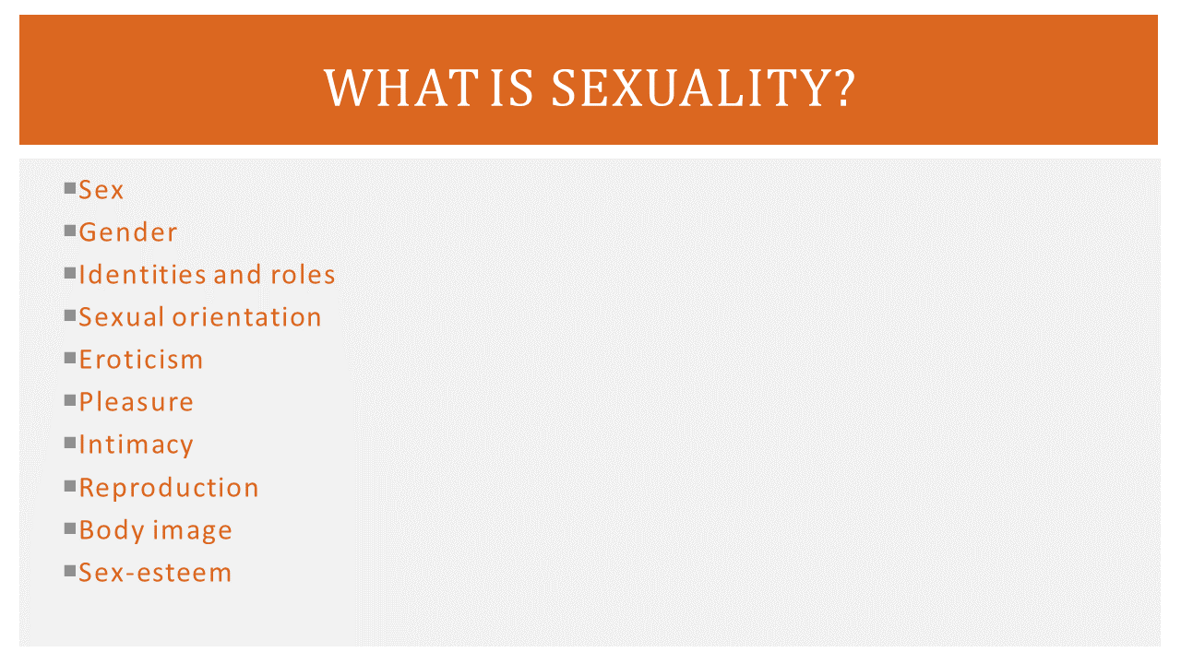
So when we think about sex in general, this is what we're assigned at birth. This is based on biology, about what we see on the body. They look for the genitalia birth and we're assigned a sex, whether it is the sex that we identify with or not, that is what is given to us at the time of our delivery. But if you think about it, there's also gender. And you may be seeing this right now, about people talking about gender and what that means, whether they're masculine or feminine, or they're deciding whether or not they have characteristics of both. And it's a range of characteristics that define somebody that way. But it's also about how they express themselves through their gender expression as well.

But then we can look at identities and roles and think about, "Well, who am I? Do I identify myself as a she, her, hers? Do I identify myself as a male, a him, he, or his? Or do I identify myself in the terms of they?" And trying to understand where we fall in the expression of our identity, where we fall with our roles, how does that impact who we are based on how we view ourselves internally. And then, we need to think about what sexual orientation is. And thinking about sexual orientation is who we are sexually attracted to. Do we look to males? Do we look to females? Are we interested in both? And trying to understand where our sexuality lies, about where our interest is.

Melissa Donahue:
But just because we have a particular sexual orientation does not mean that our eroticism necessarily matches it. For some people, they have eroticism that doesn't match. Where they may identify as that they like somebody of the opposite sex of themselves, but they find eroticism in watching same sex movies or looking at pictures that way. So trying to understand that there's lots of different levels to this and they all don't necessarily need to be congruent or equal. They could be different. So while we're trying to figure out what we find as arousing is also making sure that we're looking at the pleasure piece to being sexual or having sexual activity. It's very important to be thinking and focusing on, "What do I enjoy sexually? What are the acts that I like to receive? And what are the acts that I like to give?"

Now, lots of people will interchange sex with intimacy. And the reality is that intimacy can be a part of sex, but not always. For a lot of times, people look at sex as the physical act and intimacy is something where you have a skin hunger or a craving to be physically or emotionally close to somebody, having a connection. So there are many times that you can have intimacy without the physical act of sex, or you can have the physical act of sex with no intimacy. So they don't always go together in a sexual encounter. And then, when we think about reproduction, this is about the biology or how we talk about having sex, when we were taught sex in schools or possibly through our parents. We talk about it through the reproductive lens, of using sperm and egg in order to create conception and have a child. There's no discussion of pleasure there. It just all talks about the body mechanics and how the biology works together.

Then we go to body image. And this is a big piece, because this can sometimes affect a lot of what we do physically with other people. We have to look at how we see ourselves in our physical appearance, how do we feel in our own skin. Do we like what we see? Do we criticize what we see? Do we find parts of ourselves attractive or not? And then, lastly, where there's this sexual sex. We call it sex-esteem. And what's important about it is this is how we feel about our ability to be a sexual being, how our ability is to perform with others, perform by ourselves. And it's really important to realize how all of these things intersect together to be a sexual being. Because as a human, we are all sexual beings, whether we are sexual alone or we are sexual with a partner. And to think about how all of this kind of comes together to define who we are.

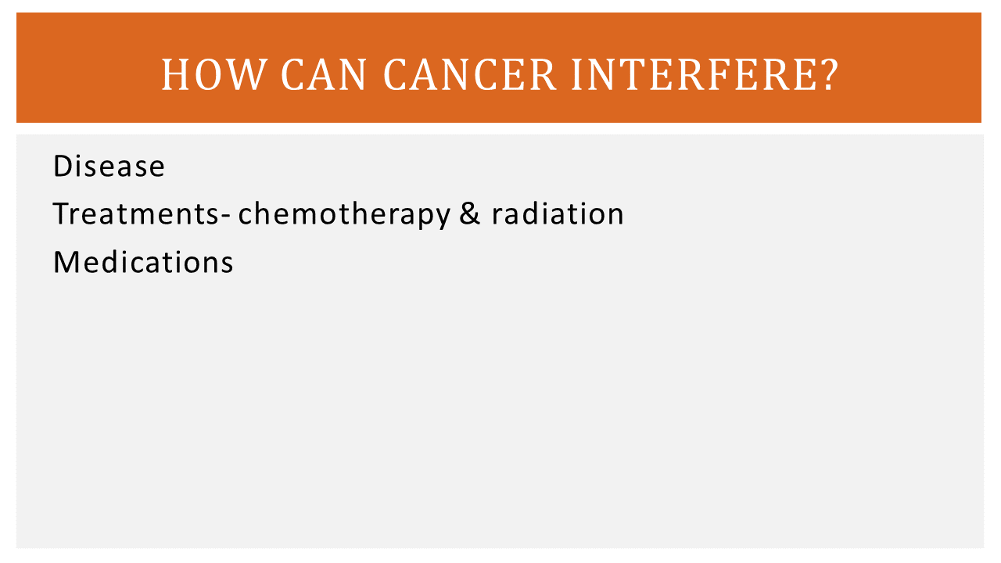
Now, the reason I broke these all down individually is because very often when we think about sex, people think about it in the terms of penetration only. When you think about it in the terms of oral penetration, vaginal penetration, or anal penetration. And the reality is that there's so much more to what sexuality really is. So now that we know what really incomes to being sexual, I think it's important to think about how cancer can possibly interfere with all of this.

Now, when we are thinking about a cancer diagnosis, it's important to think about it in different ways that the sex can be impacted by different levels of this. Very frequently, when you come with a diagnosis of cancer, the first thing that we think about is the disease. "Where is the disease located? How is the disease functioning within my body? How is the disease taking over parts of my body and interfering with the organs that it is interfering with or the surrounding organs in tissue?"

Melissa Donahue:
And it's important to talk about the location, the growth, and the interference, because very frequently, as the growth gets larger, it can move things and it can make things painful, it can make things not function the way they used to. So when we look at the disease as one particular part that could be impacting our sexuality, then there is also the treatments. There is the surgical treatment, there could be chemotherapy, or there could be radiation. And all three of these treatment modalities, while they are necessary in treating the cancer, they all have direct or indirect implications in how it affects our sexuality. And it's important to understand that yes, it could be the disease, but it could also be the treatments. And by no means am I suggesting that we shouldn't get the treatments, but to have an awareness or an understanding on how those treatments could impact our sexuality.

Additionally, there's always supporting medications that go along with chemotherapy, and sometimes radiation, or sometimes they go concurrently with other ailments that we're dealing with, whether they're psychological, whether there's pain, or there are other nerve disruptions that are causing discomfort. And understanding that all of those medications could possibly have an impact as well on how our sexuality is impacted. Very frequently, anti-depressions or anti-anxiety medication are prescribed when people have a cancer diagnosis. And though they are fabulous medications in maintaining better mental health, there are sexual side effects that are related to those medications. The same thing with any type of any hormone manipulation or any type of pain medication. So all of these things, while they work beautifully for what they are assigned to do, to fix the problem or correct a problem, there also can be impacts on us sexually. And trying to dissect how these things can impact us sexually and are their workarounds are the most important piece of this.

So about one third of patients that do go in for any type of discussion with their oncologist really do feel like there is not a discussion about sexuality and really feel that this is a piece that needs to be discussed more thoroughly with patients to be able to have better quality of life. And when you think about how all these interferences happen, it's important to realize there could be a physical interference, a neurological interference, a vascular interference, or it could be related to the endocrine system. So there's lots of different systems involved with one particular cancer that can really interfere with how the treatment can manipulate that.

Okay, so the next slide, we're talking about how cancer is not just a medical diagnosis for the body, it's not just the biological aspect, but it's beyond the body. It also infects the mind. And the reason we talk about the mind-body connection is that it's really important to think about how sexual functioning really is a biopsychosocial phenomenon.

Melissa Donahue:
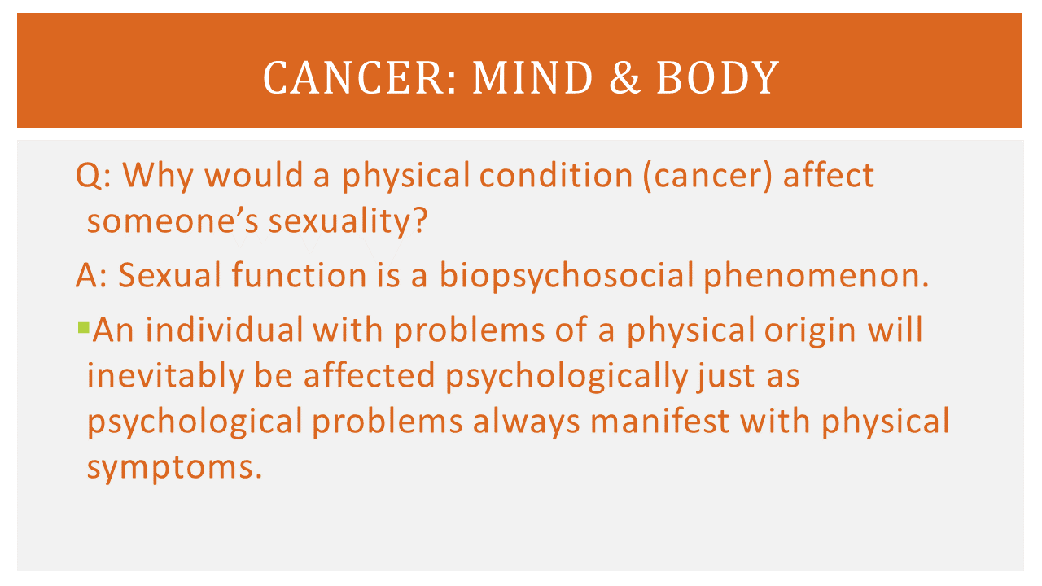
And the reason we need to break it down like this and how this interferes when it comes to cancer is that if you're looking at sexual function from a biopsychosocial phenomenon, the bio part is the biology. It's how the body is and how the body is performing. So from a physical standpoint, are all the things in alignment that need to be in alignment for our body to work? When you're talking about the psych part of the biopsychosocial, we're talking about the mind. We're talking about how the psychology is working in the mind. Are we of clear mind? Are we able to focus? Are we having any mental health interferences or components around that as well? And lastly, it's the social aspect, and that is the environment that you're living in, the environment that you're sleeping in, the environment being your relationship too. And all those things together really affect somebody's ability to be a sexual person.

So it's very important when someone is diagnosed with a cancer diagnosis to be able to identify, "Is this sexual problem something that happened prior to my diagnosis with cancer or did this happen within the scope of my diagnosis, treatment, or aftercare?" Because there are many times there are sexual issues that are happening prior to a diagnosis that could be related to an undiagnosed cancer, but it also could be related to a relationship or social issue that has been going on, that just seems to get more exacerbated with the cancer diagnosis. So it's very important to be able to understand where is the beginning part to the sexual issue, to see if it manifests with the diagnosis or not. So it's very important to be able to see how all these three things intersect with one another and how the body and mind connection really speaks.

Very frequently, patients will come into my office and we'll talk about how sometimes when something is going on with the body, we don't feel right in the mind. And sometimes when something's not going well in our minds it speaks through our body. And it doesn't necessarily have to be something such as a cancer we're talking about per se, but sometimes people have undiagnosed rashes that they can't necessarily figure out, or sometimes people are having GI issues, or they're having chronic headaches and they're having issues with sleep, and trying to explain to people that your body or your mind is trying to talk to you into a way to get you to pay attention. So trying to see how the body is fully interconnected with all of these aspects and to pay attention to these things, which is why it's important to speak up.

So in order to understand the whole piece of sexuality, now that we understand how sexuality is broken down and we understand how the body and the mind and our environment are all interconnected, it's trying to figure out... It's like, "Well, how do we know that there's a sexual problem? Do we just know or can we be able to categorize it to be able to speak to professionals about what is exactly going on?"
Melissa Donahue:
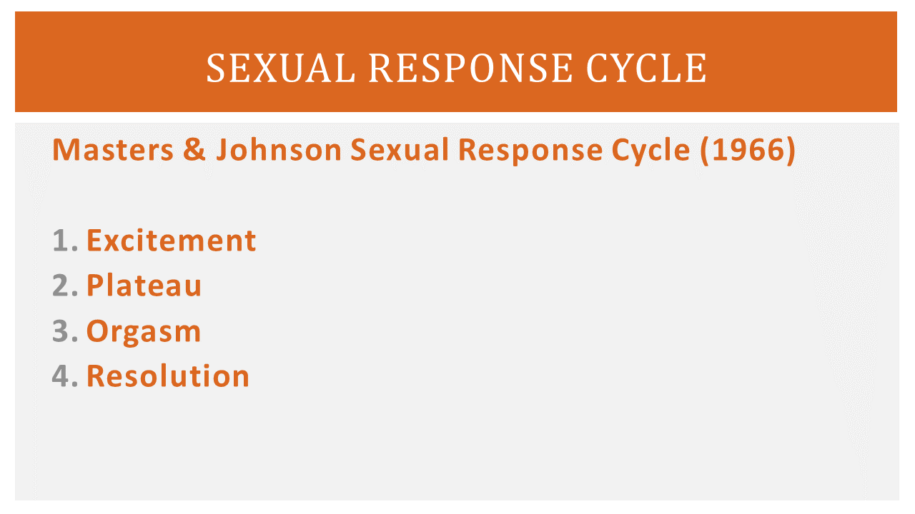
So what's really important is that the sexual response cycle, which was created by Masters and Johnson back in 1966, talked about these four different areas where there could be an issue about sexuality. And they talk about the first one being excitement, which is another way of defining what arousal is. And when we think about arousal, we think about men getting erections, women becoming lubricated or having more of a plumpness down by their vulva and their vaginal opening, and being able to have that feeling of physical ability to want to be sexual with somebody. So if we were to talk about an issue that happened in the excitement phase, this is where we would be talking about erectile dysfunctioning or not being able to maintain an erection. Sometimes women will talk about their struggles or inability to be lubricated or to feel the physical arousing experience. And sometimes, this is a good place to be able to talk to someone. So to understand that is one area where there could be an issue.

The next thing is called the plateau. I like to call this space between. This is where you're being sexual but you have not reached full orgasm yet, but you're still within the interest or the excitement or arousal phase. So typically in here, sometimes people linger here too long, sometimes people feel like they never leave this phase. And this could be related to a medication, such as an antidepressant medication or something to that effect. Sometimes there's a medication disruptor that keeps people stuck in plateau.

The third phase is the orgasm phase, and this should be the release, for men having a release, for women having a release. There are some women that say that they struggle to have orgasms, that their orgasms could be muted, they're not distinguishable as they were before, or perhaps they've never had an orgasm. So that would be something else about trying to understand and identify what is getting in the way of that.

The last one would be the resolution, I like to call as the afterglow. The resolution is the period from the ejaculation or the orgasm until the next period of excitement. And for some people, it could be a very short period of time or it could be an extended period of time, which could be related to age or it could be related to health of the individual.
So these are the four areas. But in 1979, there's a woman called Helen Singer Kaplan who said, "Well, wait a second, nobody talked about an interest in sex. And I think it's really important to say, 'There needs to be an interest, people just don't get aroused.'" So she believes that the idea of desire belonged before excitement. So that would be something where people would say that they were in the mood for being sexual and trying to explain that people should feel a sense of desire before they have arousal.
Melissa Donahue:
Well, while that does sound like it should work, not all men and women are created equal and both feel the same way. For a lot of people who identify as male, they would say, "Well, I feel an excitement or a desire for sex." And sometimes they're together and sometimes the desire for sex comes before the arousal and sometimes they chase one another. Very frequently for people who identify as female, they may say, "Well, I don't actually feel desire for sex. I don't ever have an interest in sex. But if I become sexual with my partner and I get aroused, the desire for sex then soon follows." So it doesn't necessarily always belong before excitement or arousal. It can sometimes be either a shared experience or it can come after.

Okay, so on the next slide, what's really important is, and we had talked about this before, is talking about our body image. Now, very frequently I hear people say, "Oh gosh, when I was in my early years, I thought I was overweight. I was not in shape. I did not find my body sexy." And there was lots of criticism and critiquing of our bodies. And I find as people age they say, "Oh my gosh, if I can go back to the body that I didn't love 10 years ago, 20 years ago, oh the things that I would think now." And the reality is that you need to be able to define what is sexy. You need to define that for yourself and to be able to define that for someone you want to be sexual with. I think it's very important to understand what sexy is. Is it just a physical thing? Is it a attitude? Is it a state of mind? Is it somebody's personality? How they treat other people?

Because the external part of sexy or the body of sexy is sometimes just a wrapper. It's just a wrapper to the soul of the person, and to really understand that. And sometimes who is the one defining sexy? Are we looking to meet the media to let us define who sexy is? Or are we looking to our friends or family to define what sexy is? I think it's very important to understand whose definition are we working from, are we working from our own or somebody else's. And then when you think about the sexy in you, as your body is changed, as things look different, are you able to identify something in your body that you still find attractive? Very often, I would say to patients, "Okay, so what was sexy before and what have you possibly overlooked and not give attention to now because you were always focused on one aspect of you?" So think about the sexy part of who you are now and how you can enhance it. Is it that you could add a lipstick to make your lips stand out? Could you add earrings to draw attention up towards your face? Is there a particular hat you can wear that would really just make everything come together in the way you dress? And then, once you're able to identify whether the sexy is within you, is to be able to see how others will find the sexy within you. Very frequently, it's your state of mind about how you feel about being sexy and your confidence in being sexy that does attract other people. You hear it very often, that somebody's confidence within themselves shines through as being sexy, and trying to understand and be able to see that.
Melissa Donahue:
I think it's very important to think about when it comes to body image, is that if you've ever been around children or babies, you never hear babies say, "Do I look fat in this onesie? Does this diaper make my butt stick out too much?" Sexy is very personal and it's a learned thing within the society. So making sure that you stay true to who you are and what you believe is sexy is the most important thing.

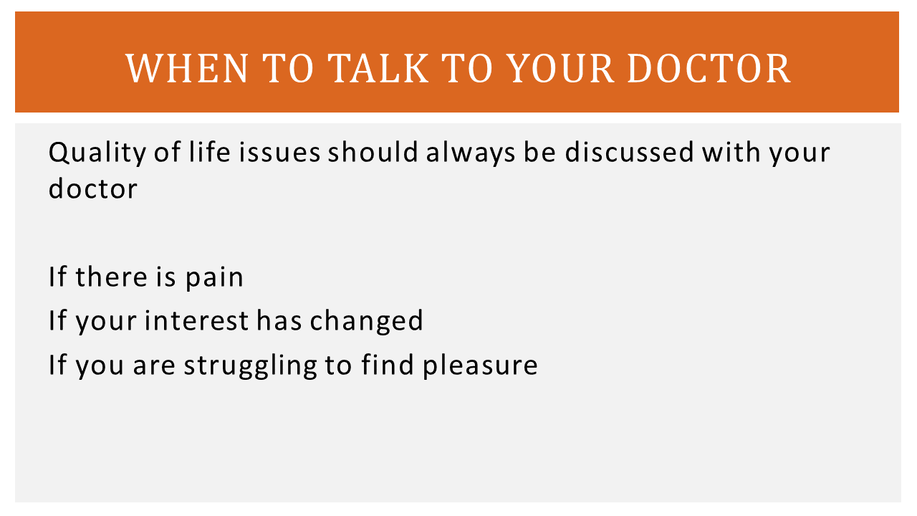
So when we think about talking to our doctor, on the next slide, it's important to think about quality of life. Being a sexual being is a quality of life issue. And it should definitely be discussed with your doctor, just like whether or not you can swallow, whether or not you are able to use the bathroom and have a bowel movement, whether or not you can eat, your sleep. All of those things related are all quality of life and sex is part of that. And it's important to make sure that your doctor knows if you are having any pain when you're being sexual, where the pain is, how does the pain persist, does it pass, is it temporary, is it permanent when you're trying to be sexual.

If your interest in sex has changed, it's really important to be able to tell your doctor, "I used to be more sexually active. I used to be wanting to see my partner more often, but now something is different." Or if you're being sexual and you're just not finding any enjoyment in it, it's definitely worth talking to your doctor. These are ways to be able to indicate, when we go back, when we were talking earlier about the sexual response cycle, being able to see where all these things interfere with being sexual. Because if there is pain, even if it's not in the area where you are being sexual, but there are pain somewhere else, it is very hard to want to relax and enjoy pleasure, accepting pleasure, especially if you're physically experiencing any pain.

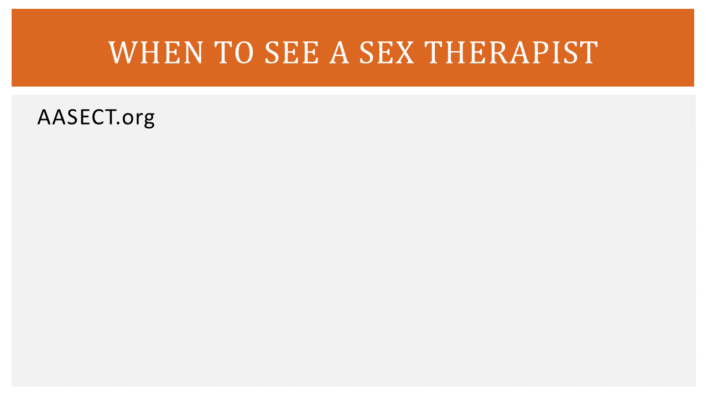
Okay, so we had talked earlier about this organization called AASECT. AASECT is an organization where they are able to identify certified sex therapists, certified sex counselors, and certified sex therapists. So there's educators, counselors, and therapists all across the United States. If you were to go to their website and you were able to see, they do break it down by state. So you can possibly find a particular professional within your community. Some of them may or may not understand oncology, but they definitely understand sexuality and can definitely walk you through that process and be able to help you identify if you're struggling with that area. It's definitely very important to make sure that the professional that you are speaking to really does understand sex. I find that just like oncology, sexuality training is very specific and just because people are sexual does not mean that they necessarily know how to counsel patients on being sexual. So I think that's very important to consider.
Melissa Donahue:
So when we're thinking about working with a sex therapist, do we really need to work with a sex therapist, there are other things that we can do in the meantime to see if we can rearrange how we are being sexual and what is important to us in our sexuality. I think it's important to start off with reframing what sex is and what sex is not. Very often, patients just want to be able to have penetrative sex. And I always say to people, "The goal is not penetration and the goal is not orgasm. The goal should always be pleasure." And if you're focusing on sex as a pleasure focused activity, like an adult play date, you will likely not be disappointed and you will not be feeling like you are less than.

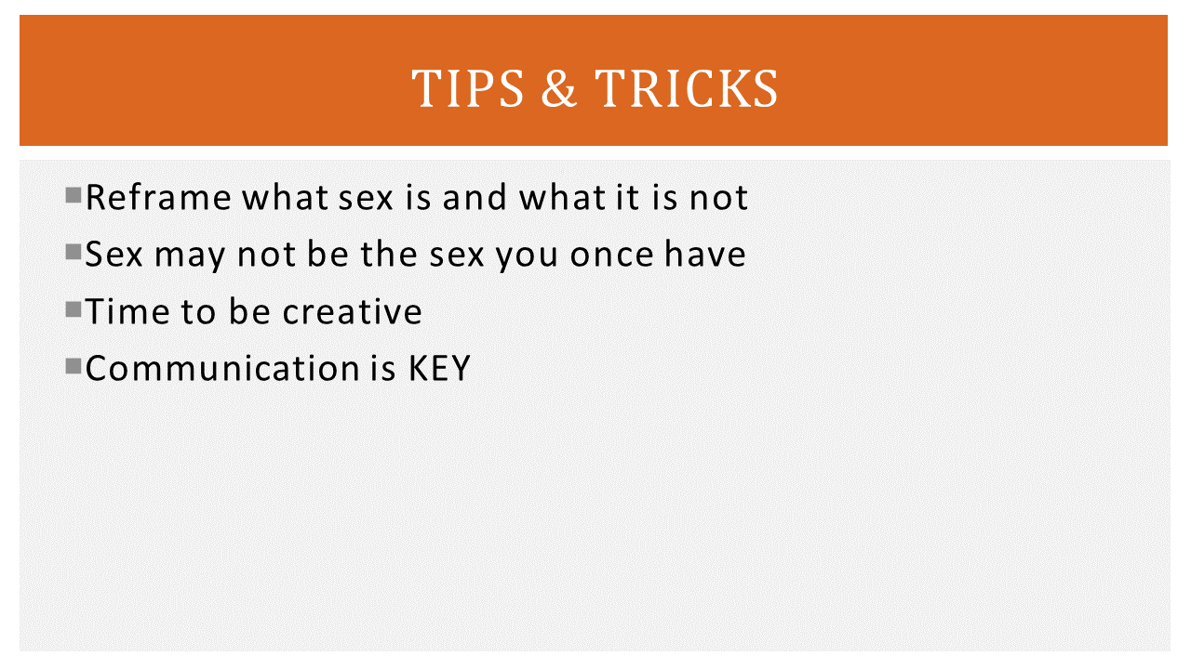
Because sex really is about the physical and emotional connection with your partner. It's not necessarily being able to be penetrated or penetrate something else. So when you're able to pay attention to the other skin parts of the body, the other parts that you frequently have ignored in the past, sometimes you're able to find a lot more pleasure in different ways that you've never expected. I frequently tell patients, "If you've always focused on the front of your partner, flip your partner over and see what it feels like to do sensations of kissing, light touch, scratchy touch different sensations on their back or their lower back, and see how they respond. Frequently, people do not do that. Or put them on their side if they can't lay flat on their stomach, to be able to touch their back." And for some people, it feels very soothing, very relaxing. And for some people, it's very arousing.

Thinking about sex may not be the sex you once have. If we're always focused on the type of sex we've had before and we're not able to have that kind of sex going forward for whatever the reason it's going to feel disappointing. It's going to feel like a loss and you're going to want to grieve. And I think that's a very normal response to changes. So I think you need to be able to have space with that and be able to honor the fact that things are different. And to be able to be there in the grieving process before you move on. Just being able to hear, "Well, there are different things," does not fix the problem. You need to be able to grieve the change and grieve the loss that you perhaps once had. And to be able to say, "Okay, well, now when I feel like I understood that, let's see what else is out there."
And it's time to be creative. This is the time to start thinking about ways that you can be creative with your sexuality, perhaps using... They have different card decks of different ways that you can be sexual. And it's not just positions, but it's ways to enhance sensation play or perhaps using all of your five senses and being able to create a sexual environment. This is the time of creative be is being the key.
Melissa Donahue:
But in addition to that, being able to communicate with your sexual partner and saying what you like, saying what you want to try, and being able to have an open communication in the bedroom and outside the bedroom. Because if you don't feel safe with your partner with your clothes on, you're not going to feel safe with your partner with your clothes off.

So in closing, there's a few books and extras that I want to make sure that everybody is aware of. The book on the top is called The Guide to Getting it on. It's by Paul Joannides. And it's in its 10th edition now, which I think is really important to point out, that this book keeps getting revisions and revisions and revisions. But I like to call this bisexual bible, because this is all the information that no one teaches you about sex. The book looks like a textbook, if you were to look at it and you were to purchase it, but it is written chapter by chapter on all different topics. And it starts with kissing and it goes all the way through sex in the later years. There may be a chapter on cancer, I'm not 100% sure off the top of my head, but it's the basics of sex.

And the reason I suggest this book is because people need to understand the basics to be able to move beyond. If you're only looking at sex with the lens of penetration, you're going to miss everything in between. And this book is written as if your friend is talking to you. It is not an academic book whatsoever, though it looks very large. It is great with its visualizations, that there are more cartoon style drawings, so they're not offensive in the pictures that they're providing. And many people, regardless of cultural experiences or religious experience, find the book to be written very user friendly.

The other book I'm going to suggest, it's called Sex for One by Betty Dodson. And this book is a great book about teaching self pleasure and learning to be able to explore yourself. It's written for women, but there are lots more to the idea of sex for one. I think it's a situation where people don't necessarily want to believe or talk about out loud, that people are sexual alone. People don't like to believe that people across a certain age threshold or if they lose their partner, that they're nonsexual beings. But I think people are sexual beings as long as they want to be. There is no age cutoff, where we kick you out of the membership club of being sexual. And I think it should be something to discuss. So I want to make sure that masturbation is something that you continuously explore with yourself, to be able to find what is comfortable and what is not, and to be able to share that with your partner.

Lube, Lube, Lube. I think it's very important to make sure you have high quality lube and to not make sure that you are buying lube that is going to be irritating. For some people, there are certain brands that cause urinary tract infections, yeast infections. Make sure that you're buying the proper lube for your body. Making sure that you understand how your body responds to whether if it's water based or not.
Melissa Donahue:
And also, to make sure it's compatible with your sex toys. Sex toys are very important. They're really great for being able to enhance a sexual experience, being able to perhaps give pleasure, especially if people's hands are tired or there is arthritis. There's lots of different manipulations to make them build them up and make them even easier for their hand maneuvers.

And imagination is the key. If you do not have an imagination and you can't go beyond, it's very hard to be sexual. Sex is really about the most imaginative thing you can do. I want you to take your imagination and see where it can take you, because that is one of the biggest and greatest tools you have in being a sexual being. So I think that is the last slide.

